**Task # 1:** Take two inputs and Subtract

**Code:**

In Input Data A

sto 98 store input at adress 98 in Ram

In Input Data B

sto 99 Store input at adress 99 in Ram

lda 98 Load Address 98 (Data A)

sub 99 Subtract A with 99 (B)

out Display Output

hlt Terminate Program

**Output:**

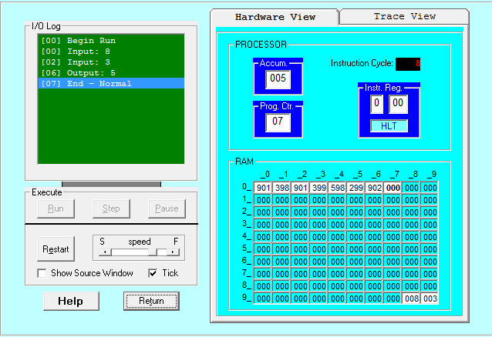

**Task # 2:** To take two hardcoded input and Add them.

**Code:**

lda 98 load address 98 value 1 stored there

add 99 add 99 (value 2 stored here) waith value 1

out print output

hlt terminate program

*98

Dat 008 Store data 1 at adress 98

Dat 009 tore data 2 at 99

**Output:**

